Letter to the Editor

Bat reservoirs related to SARS-CoV-2
Reservorios de murciélagos relacionados con el SARS-CoV-2

Sebastián Iglesias-Osores¹* https://orcid.org/0000-0002-4984-4656

¹Facultad de Ciencias Biológicas. Universidad Nacional Pedro Ruiz Gallo. Lambayeque, Perú.

*Correspondencia. Correo electrónico: sebasiglo@gmail.com, siglesias@unprg.edu.pe

Dear Editor,
Bats are mammals documented to be infected by coronavirus SARS-like related to SARS-CoV-2 which cause COVID-19.⁽¹⁾ Bats represent about 20% of all classified mammal species, over 1,200 species. They are largely fruit-eating, seed dispersers and pollinators around the wold,⁽²⁾ this made this species important in the ecosystems ecology.
When the COVID-19 pandemic was declarated in december 2019, the search for origins was found in sequencing of coronavirus related to bats. This suggests that these animals may be long-term reservoir host for the coronavirus SARS-like betacoronaviruses and may recombine between species of bats.⁽¹⁾ The species of bats related to the coronavirus SARS-like are Rhinolophus affinis and Rhinolophus sinicus and are distributed principally in China, Europe and Africa (Fig. 1).⁽³⁾ The sequences of new coronavirus has been submitted to GISAID and GenBank. The most emparented coronavirus SARS-like is BetaCoV/bat/Yunnan/RaTG13/2013 found in Rhinolophus affinis with 96.2% (accession MN996532) similarity with WH-Human_1 (SARS-CoV-2) (accession MN908947) (Fig. 2) the first sequencing sample in humans, although the SARS-CoV-2 was closer to the bat_SL_CoVZC45 (accession MG772933) and the bat_SL_CoVZXC21 (accession MG772934) both found in Rhinolophus sinicus.⁽³⁾ The genus Rhinolophus (horseshoe bats) in the family Rhinolophidae demonstrated a high posibility to be the host of SARS-like betacoronaviruses⁽⁴⁾ and could cause a future disease outbreak. We have to focus on possible mutations and hosts that may cause pandemics in the future and their zoonotic role.

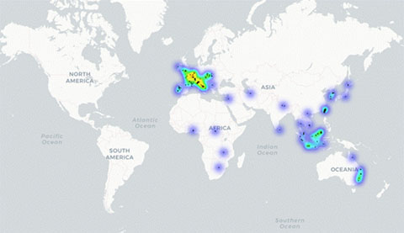
Fig. 1 - Distribution of species of the Rhinolophidae family in the world.

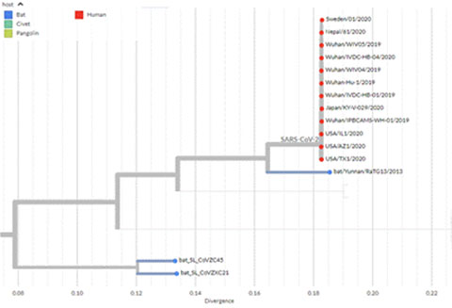
Source: https://nextstrain.org/groups/blab/sars-like-cov
Fig. 2 - Phylogeny of SARS-like betacoronaviruses including novel coronavirus SARS-CoV-2.

BIBLIOGRAFIC REFERENCES
1. Zhou P, Yang X Lou, Wang XG, Hu B, Zhang L, Zhang W, et al. A pneumonia outbreak associated with a new coronavirus of probable bat origin. Nature. 2020 Mar 12;579(7798):270–3.
2. Hodgkison R, Balding ST, Zubaid A, Kunz TH. Fruit Bats (Chiroptera: Pteropodidae) as Seed Dispersers and Pollinators in a Lowland Malaysian Rain Forest1. Biotropica. 2003 Dec [access: 04/05/2020];35(4):491–502. Available from: http://doi.wiley.com/10.1111/j.1744-7429.2003.tb00606.x
3. Hu D, Zhu C, Ai L, He T, Wang Y, Ye F, et al. Genomic characterization and infectivity of a novel SARS-like coronavirus in Chinese bats. Emerg Microbes Infect. 2018 Dec 1;7(1):1-10
4. Li W, Shi Z, Yu M, Ren W, Smith C, Epstein JH, et al. Bats are natural reservoirs of SARS-like coronaviruses. Science (80- ). 2005 Oct 28;310(5748):676–9.

