Artículo de investigación

Metabolic syndrome prevalence in military personnel and correlation with anthropometric values in Ecuador
Prevalencia de síndrome metabólico en el personal militar y correlación con valores antropométricos en Ecuador

German Geovanny Muñoz-Gualan¹* https://orcid.org/0000-0002-2217-1412
Alberth Patricio Muñoz-Gualan² https://orcid.org/0000-0002-3822-6326

¹University of Armed Forces ESPE. Military Health Department. Loja, Ecuador.
²Peoples’ Friendship University of Russia. Division of Nervous Diseases and Neurosurgery. Moscow, Russia.

*Author for correspondence. Email: gergeomunoz1988@gmail.com

ABSTRACT
Introduction: Fat excess in the organism can behave as a multifactorial problem and predisposes to the presence of non-transmissible chronic diseases, in which cardiovascular diseases can be mentioned.
Objective: To establish the optimal cut-off for anthropometric indices to predict Metabolic Syndrome in army personnel, attended at the primary health care.
Method: An analytical, non-experimental study that was carried out in army personnel at the University of the Armed Forces, during the year 2020. The sample was represented by 203 participants, the collection methods were the medical and anthropometric records, taking into consideration variables such as height and weight, hip and waist circumference, body mass index, laboratory tests, among others. All the data was analyzed using international classification criteria.
Results: The prevalence of MetSyn was obtained, according to the different criteria: MetSyn ALAD: 4.08% (SD: 0.52), MetSyn ATP III: 7.65% (SD: 0.52), MetSyn HARM: 5.4% (SD: 0.52) and finally, MetSyn OMS: 7.65% (SD: 0.52). Likewise, the predictive anthropometric indices according to the highest AUC are the WC and WHtR in all the criteria studied, in addition, according to MetSyn ATP III, the optimal WC cut-off is 91 cm and the WHtR is 0.53.
Conclusions: The optimal cut-off for anthropometric indices that predict Metabolic syndrome in army personnel are WC and WHtR, with an optimal cut off lower than the criteria established by ALAD to the diagnosis of MetSyn.
Keywords: metabolic syndrome; anthropometric indices; military instructors; optimal cut; Ecuador.

RESUMEN
Introducción: El exceso de grasa en el organismo puede ser un problema multifactorial y predispone a la presencia de enfermedades crónicas no transmisibles, entre las que se encuentran las cardiovasculares.
Objetivo: Establecer el corte óptimo de los índices antropométricos para predecir el síndrome metabólico en personal militar que se atiende en la atención primaria de salud.
Métodos: Estudio analítico, no experimental, llevado a cabo en personal militar de la Universidad de las Fuerzas Armadas, durante el año 2020. La muestra está representada por 203 participantes, los métodos de colección fueron los registros médicos y antropométricos, tomando en consideración variables como talla y peso, circunferencia de cintura y cadera, índice de masa corporal, pruebas de laboratorio, entre otros. Todos los datos fueron analizados usando criterios de clasificación internacional.
Resultado: La prevalencia de síndrome metabólico (MetSyn), según los diferentes criterios es: MetSyn ALAD: 4,08 % (SD: 0,52), MetSyn ATP III: 7,65 % (SD: 0,52), MetSyn HARM: 5,4 % (SD: 0,52) y finalmente, MetSyn OMS: 7,65 % (SD: 0,52). Además, los índices antropométricos predictivos son el WC y WHtR en todos los criterios estudiados, y según MetSyn ATP III, el corte óptimo del WC es de 91 cm y del WHtR es de 0,53.
Conclusiones: Los puntos de corte óptimos para los índices antropométricos que predicen el síndrome metabólico en el personal militar son WC y WHtR, con un punto de corte óptimo inferior a los criterios establecidos por ALAD para el diagnóstico de MetSyn.
Palabras clave: síndrome metabólico; índices antropométricos; instructores militares; corte óptimo; Ecuador.

Received: 16/09/2022
Approved: 13/03/2023

INTRODUCTION
Fat excess in the body can be harmful in the population’s health, which behaves as a multifactorial problem and predisposes to the presence of non-transmissible chronic diseases.⁽¹⁾
Among non-transmissible chronic diseases, it can be mention cardiovascular diseases (cardiomyopathy and cerebrovascular accident), metabolic diseases (type 2 diabetes mellitus, dyslipidemia, hyperuricemia and metabolic syndrome), musculoskeletal, digestive and neoplastic diseases, which represent a high morbidity and mortality prevalence in the general population.⁽²⁾
The study of fat excess in the population is possible using a fast, easy and inexpensive method by quantifying anthropometric indices, of great importance in primary care due to the possibility of screening cardiovascular and metabolic diseases.⁽³⁾
Differences in fat excess depend on non-modifiable factors such as age, sex, race and genetics, which implies an important value in clinical practice, as it is pathophysiologically implicated in resistance to insulin action mediated by b-cell lipotoxicity, pancreatic diseases, as well as promoting a chronic inflammatory state mediated by adipokines and other substances such as leptin, resistin, angiotensinogen, pro-inflammatory cytokines and chemokines.⁽⁴⁾
The assessment of anthropometric indices is very useful in primary care and epidemiological research, it helps to predict a number of cardiometabolic diseases and allow the construction of prevention interventions.⁽⁵⁾
Body mass index is widely used among obesity indicators, and can vary according to the age, sex, and body biotype of certain individuals, so it is necessary to complement the analysis with the measurement of abdominal circumference, because it has less variation influence, however, for a better clinical evaluation, other indices such as waist-height index, waist-hip index, body fat percentage can be used.⁽⁶⁾
Cardiovascular diseases cause a considerable global mortality, with 31% of deaths due to this condition, and 71% of them occur in countries with low and middle income. Furthermore, 85% of all disabilities are caused or related to cardiovascular disease.^{(7,8)}
Currently, it is known that the metabolic syndrome (MetSyn) is a condition characterized by the presence of cardiovascular and metabolic factors such as arterial hypertension, hypertriglyceridemia, hyperglycemia, abdominal obesity and high-density cholesterol. The metabolic syndrome presents a heterogeneous prevalence, thus according to the meta-analysis carried out by Hosein et al.^{(10).} in 2020, MetSyn was estimated at 8.3%, and according to Baygi et al.⁽¹¹⁾ in the same year the global prevalence of MetSyn was 21%.^{(9,10,11)}
In the Ecuadorian context, there is no consensus on the prevalence and optimal predictive anthropometric values of MetSyn in the general population; but the prevalence of dyslipidemia and MetSyn in military personnel is low compared to the general population.^{(12,13,14)}
Therefore, this study determines to establish the optimal cutoff of anthropometric indices to predict Metabolic Syndrome in army instructors of Military Sciences career at the University of the Armed Forces in Ecuador.

METHODS
This is an analytical, non-experimental study. It was carried out in the instructors of Military Sciences career at the University of the Armed Forces, located in Ambato city - Ecuador, during the year 2020. The population of the study was 366 instructors, with a sample of 203 (95% confidence level and 5% margin of error).
The variables analyzed were:

- Height and weight (measured without shoes and in underwear).
- Hip circumference (HC), waist circumference (WC), measured with a non-elastic measuring tape at the level of the widest part of the buttocks and at the level of the iliac crests respectively, which is classified as: a) low (WC ≤ 93 in men and ≤ 79 in women), b) high (WC ≥ 0.94 in men and ≥ 0.80 in women).⁽¹⁵⁾
- Body Mass Index (BMI) = weight (kg) / height² (m), which was classified into 4 groups (underweight: ≤ 18.5, normal weight: 18.5-24, overweight: 24-30 and, obesity: ≥ 30).⁽²⁾
- Waist-hip ratio (WHR) = waist measurement (cm) / hip measurement (cm), which was classified into 2 groups (high: ≥ 0.95 in men and ≥ 0.90 in women, low: ≤ 0.95 in men and ≤ 0.90 in women).⁽¹⁶⁾
- Waist index height (WHtR) = waist measurement (cm) / height (cm), which was classified into 3 groups (high: ≥ 0.52, low: ≤ 0.48, and normal: 0.48 - 0.52).⁽¹⁷⁾
- Waist circumference weight index (WRWC) = weight (kg) / waist circumference measure (cm), which was classified into 4 groups (deficit: <0.44; normal: 0.44 - 0.80, overweight: 0.80 ≤ - <0.98, obesity: ≥ 0.98).⁽¹⁸⁾
- Body fat percentage (BFP) = 1.51 x (BMI) -0.70 x (Age) - 3.6 x (1) +1.4 (Male) and BFP = 1.2 x (BMI) + 0.23 x (Age) - 10.8 x (sex) - 5.4 (Female), which was classified into 3 groups (normal: 12-20 in males and 24-30 in females, limit: 21-25 in males and 31-33 in females, and obesity: > 35 in males and > 33 in females).⁽¹⁹⁾
- Laboratory tests: fasting glycemia, total cholesterol and triglycerides, urinalysis.
- Blood pressure (measured with a digital cuff blood pressure monitor).

It is necessary to mention that the High-Density Cholesterol-C (HDL-C) test, as it is not considered a routine lipid test in the Institution, was not evaluated in this research study.
The variable metabolic syndrome (MetSyn) was analyzed according to the pre-established criteria of the World Health Organization - WHO (MetSyn OMS), ALAD (MetSyn ALAD), ATP III (MetSyn ATP III) and Harmonizing the metabolic syndrome (MetSyn HARM).^{(20,21)}
The information collection instruments were annual medical record, carried out during the month of October 2020 (laboratory tests, and medicine, dental and mental check-up), and anthropometric record, carried out in November 2020, which analyzes the general nutritional status by evaluating folds (triceps, supra scapular, supra iliac, abdominal, thigh and leg), diameters (fist, elbow and knee), perimeters (thigh, arm and calf) as well as abdominal and hip circumferences.
The pre-established inclusion criterion is to be instructor of the Military Sciences career at the University of the Armed Forces. On the contrary, the instructors with incomplete annual medical records and incomplete anthropometric records were excluded.
The information was obtained with prior authorization from the director of the Institute and the Institute's ethics committee.
The statistical analysis was performed with the SPSS -version 22- and MedCalc programs, the variables are expressed as mean ± SD for continuous variables, which were compared by Student's t test. In addition, the analysis of the receiver operating characteristics (ROC) curve using the Youden index to determine the optimal cut-off point of the anthropometric indices in the diagnosis of metabolic syndrome were considered statistically significant (< 0.05).

RESULTS
According to the ALAD criteria 8 male instructors had MetSyn (%: 4.08, SD: 0.52), with a mean age of 41 years (SD: 4). According to the ATP III criteria 15 males presented MetSyn (%: 7.65, SD: 0.52), with a mean age of 41 years (SD: 4). According to HARM criteria there were 11 males with MetSyn (%: 5.4, SD: 0.52), with a mean age of 41 years (SD: 4). Finally, according to WHO criteria, there were 15 males (%: 7.65%, SD: 0.52), with a mean age of 40 years (SD: 5), however, no women presented diagnostic criteria, and they were excluded from the study because they represented a very small proportion within the sample (n: 7).
Likewise, the most prevalent criterion was triglycerides, according to MetSyn ALAD with 3.4% (n: 7, SD: 0.35), according to MetSyn ATP III with 6,9% (n: 14, SD: 0.26), according to MetSyn HARM with 4.9% (n: 10, SD: 0.30), and according to the MetSyn WHO with 7.4% (n: 15, SD: 0.00).
The more prevalent anthropometric indexes according to MetSyn ALAD are WC with 3.9% (n: 8, SD: 0.0) and WHtR with 3.9% (n: 8, SD: 0.0), according to MetSyn ATP III overweight with 6.4% (n: 13, SD: 0.35) and WHtR with 7.4% (n: 15, SD: 0.0), according to MetSyn HARM overweight with 4.5% (n: 9, SD: 0.40) and WHtR with 5.4% (n: 11, SD: 0.0), and according to the MetSyn WHO overweight with 6.4% (n: 13: 0.35) and WHtR with 6.4% (n: 13, SD: 0.35) (table 1).

Table 1 - Characteristic of the study population and MetSyn
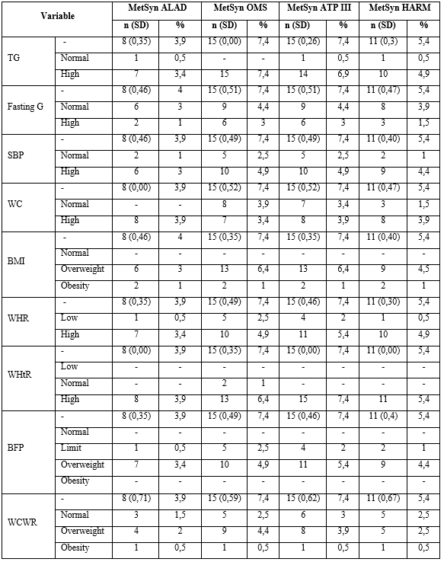
MetSyn: Metabolic syndrome, n: Number, %: Percentage, SD: Standar desviation, TC: Total cholesterol, TG: Trygliceride, Fasting G.: Fasting glucose, SBP: Systolic blood pressure, DBP: Diastolic blood pressure, WC: Waist circumference, BMI: Body mass index, WHR: Waist hip ratio, WHtR: Waist height ratio, BFP: Body fat percentage, WCWR: Waist circumference weight ratio.

When analyzing the optimal cut-off value of anthropometric indices to present metabolic syndrome, according to MetSyn ALAD the highest AUC are WC (0.915, 95% CI 0.867-0.950) and WHtR (0.85, 95% CI 0,792 - 0,897) (with an optimal cut off of 95 cm for WC and 0.56 for WHtR). According to MetSyn ATP the highest AUC is WC (0.824, 95% CI 0,764 - 0,875) and WHtR (0.783, 95% CI 0,719 - 0,839). According to MetSyn HARM the highest AUC is WC (0.849, 95% CI 0,791 - 0,896) and WHtR (0.825, 95% CI 0,765 - 0,876). Finally, according MetSyn OMS the highest AUC is WC (0.777, 95% CI 0,712 - 0,833) and WHtR (0.721, 95% CI 0,653 - 0,783) (the optimal cut off in MetSyn ATP, HARM and OMS is 91 cm for WC and 0.53 for WHtR) (Fig. 1, Fig. 2, Fig. 3, and Fig. 4).

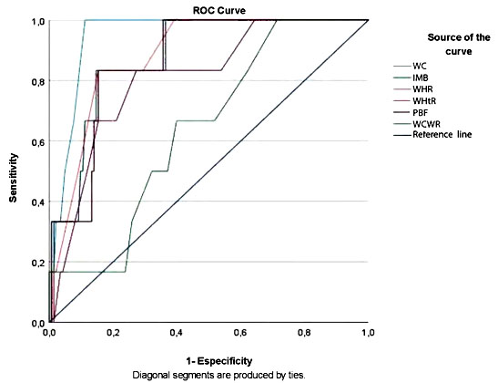
ROC: Receiver operating characteristics, WC: waist circumference, BMI: Body mass index, WHR: waist hip ratio, WHtR: waist height ratio, BFP: body fat percentage, WCWR: waist circumference weight ratio.
Fig. 1- ROC curve for anthropometric indices to predict MetSyn ALAD.

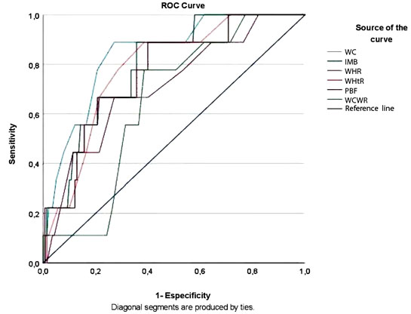
ROC: Receiver operating characteristics, WC: waist circumference, BMI: Body mass index, WHR: waist hip ratio, WHtR: waist height ratio, BFP: body fat percentage, WCWR: waist circumference weight ratio.
Fig. 2-ROC curve for anthropometric indices to predict MetSyn OMS.

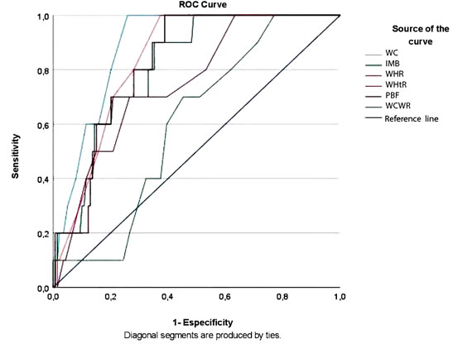
ROC: Receiver operating characteristics, WC: waist circumference, BMI: Body mass index, WHR: waist hip ratio, WHtR: waist height ratio, BFP: body fat percentage, WCWR: waist circumference weight ratio.
Fig. 3- ROC curve for anthropometric indices to predict MetSyn ATP III.

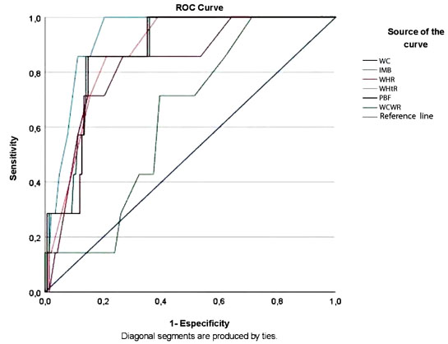
ROC: Receiver operating characteristics, WC: waist circumference, BMI: Body mass index, WHR: waist hip ratio, WHtR: waist height ratio, BFP: body fat percentage, WCWR: waist circumference weight ratio.
Fig. 4- ROC curve for anthropometric indices to predict MetSyn Harmonizing.

DISCUSSION
The prevalence of MetSyn according to the different criteria in this study, ALAD 8 male (%: 4.08, SD: 0.52), ATP III 15 male (%: 7.65, SD: 0.52), Harmonizing 11 male (%: 5.4, SD: 0.52) and finally, male WHO 15 (%: 7.65 %, SD: 0.52), differ from what was observed in a meta-analysis of Mexico in non-military personnel, where the prevalence according to the IDF criteria is 54% (95% CI 0.44-0.63), ATP III 36% (95% CI 0.30 -0.42) and WHO 31% (95% CI: 0.04-0, 81),⁽²²⁾ as well as what was observed by Herrera et al.⁽²³⁾ in 2017, where MetSyn was presented in non-military personnel in 28.7% according to the ATPIII criteria and 37.9% according to the criteria IDF.
The prevalence of MetSyn ATP III was 7.65%, is lower than that observed in a study in Iranian military personnel, where the prevalence was 11.1% and in a study in Taiwanese military personnel (mean age: 35.9 years) where the prevalence was 15%. However, this difference is more accentuated when observing a study carried out in a population of military soldiers in Brazil (mean age: 45 years) where the prevalence was 38.54%.^{(24,25,26)}
Likewise, the prevalence of MetSyn according to this study is lower than that observed in a meta-analysis in Latin American countries in non-military personnel, where it was presented in 24.9% of the population (age range: 18.8-43.3), and in a population of 10,318 non-military participants in Ecuador (age range 18-59 years) where 31.2% had MetSyn. However, it is very similar to a study in military personnel (mean age: 37 years), where 8% presented MetSyn in Ecuador.^{(12,27,28)}
According to this study, the most prevalent diagnostic criterion for MetSyn is triglycerides (MetSyn ALAD: 3.9%, MetSyn ATP III: 6.9 , MetSyn Harm: 4.9%, and MetSyn WHO: 7.4%) as well as the most prevalent anthropometric indices were WC, WHtR and BMI (MetSyn ALAD: WC of 3.9%, and WHtR of 3.9%, MetSyn ATP III: overweight of 6.4% according to BMI and WHtR of 7.4% , MetSyn Harm: 4.5% overweight according to the BMI and WHtR of 5.4%, and MetSyn OMS: overweight with 6.4% according to the BMI and WHtR of 6.4%), which are similar to those observed in non-military personnel from a meta-analysis conducted by Baygi et al.,⁽¹¹⁾ although in a remarkably high percentage, where triglycerides were present in 24%, overweight in 35%, obesity in 14%, abdominal obesity in 29% of the participants.⁽¹¹⁾
The predictive anthropometric indices of MetSyn according to the highest AUC in this study are the WC and WHtR (MetSyn ALAD: WC: 0.915, WHtR: 0.85, MetSyn ATP III: WC: 0.824, WHtR: 0.783, MetSyn Harm: WC: 0.849, WHtR: 0.800, and MetSyn WHO: WC: 0.777, WHtR: 0.721), with optimal cuts according to MetSyn ATPIII very similar to those found in other studies (MetSyn ATP III: WC: 0.91, WHtR: 0.53). Observing that in Iran, WC and WHtR had an AUC of 0.65 and 0.64 respectively as predictors for MetSyn, with an optimal WC cut of 91 cm.⁽²⁷⁾ Likewise, in another study, WC presented an AUC of 0.82 and WHtR with an AUC 0.79, in which WC presents an optimal cutoff of 89.3 cm to predict MetSyn.⁽³⁰⁾
In Ecuador, in a study in children (mean age: 12 years) the optimal cut-off values ​​to predict WC MetSyn was 92 cm and WHtR of 0.52 respectively, as well as, in older male adults (mean age 70.6 years), the optimal WC cutoff to predict MetSyn was 91.2 cm (sensitivity 73.2%, specificity 62.8%, and YI 0.36), finally, the values ​are similar to those observed in military personnel (mean age: 37 years), where the optimal cut was 92 cm for WC and 0.52 cm for WHtR respectively.^{(12,31,32)}
Additionally, it is worth to mention that military instructors have a low prevalence of dyslipidemia, overweight, obesity and MetSyn, compared to the information observed in the general population and foreign military personnel, which could be due to intrinsic cardiovascular and metabolic protection of the physical activity they do by this population group as part of their professional duties.
This study presented limitations in its development, as it was not possible to consider HDL-C in the diagnosis of MetSyn, which is not part of the routine blood test in these personnel, for which it is recommended to carry out a study where this is included lipid profile criterion. Additionally, there is not information about the use of other existing criteria (ALAD, WHO, HARM) for the diagnosis of MetSyn in military personnel in the country.
According to this study, it is concluded that the best anthropometric indices for the diagnosis of MetSyn (represented by the higher AUC) are WC and WHtR, with an optimal cut off similar to the general population, both national and foreign, however these values are lower than the criteria established by the ALAD.

BIBLIOGRAPHIC REFERENCES
1. Hernández Rodríguez J, Moncada Espinal O, Domínguez Y. Utilidad del índice cintura/cadera en la detección del riesgo cardiometabólico en individuos sobrepesos y obesos. Rev Cuba Endocrinol. 2018 [access: 15/09/2022]; 29(2):1–16. Available at: http://scielo.sld.cu/scielo.php?script=sci_arttext&pid=S1561-29532018000200007&lng=es&nrm=iso
2. WHO Expert Consultation. Appropriate body-mass index for Asian populations and its implications for policy and intervention strategies. Lancet. 2004; 363(9403):157–63. DOI: 10.1016/S0140-6736(03)15268-3
3. Bonet M, Varona P. III Encuesta Nacional de Factores de Riesgo y actividades preventivas de enfermedades no transmisibles. Cuba 2010-2011. Editorial de Ciencias Médicas. 2018. [access: 15/09/2022]. Available at: http://www.ecimed.sld.cu/2014/08/07/1897/
4. Hernández Rodríguez J, Duchi Jimbo P. Índice cintura/talla y su utilidad para detectar riesgo cardiovascular y metabólico. Rev Cuba Endocrinol. 2015 [access: 15/09/2022]; 26(1):66–76. Available at: http://scielo.sld.cu/scielo.php?script=sci_arttext&pid=S1561-29532015000100006
5. Coniglio R. Relación entre la obesidad central y los componentes del síndrome metabólico. Acta Bioquímica Clínica Latinoam. 2014 [access: 15/09/2022]; 48(2):191–201. Available at: http://www.scielo.org.ar/scielo.php?script=sci_arttext&pid=S0325-29572014000200004
6. Marques López I. Diámetro abdominal sagital: un indicador de grasa visceral que se debe tener en cuenta en la práctica clínica. Rev Española Nutr Humana y Dietética. 2012; 16(4):121–2. DOI: 10.14306/renhyd.16.4.54
7. WHO. Cardiovascular diseases (CVDs). Fact sheets/ Detail. 2017. [access: 15/09/2022]. Available at: https://www.who.int/news-room/fact-sheets/detail/cardiovascular-diseases-(cvds)
8. Hussain M, Oldenburg B, Wang Y, Zoungas S, Tonkin A. Assessment of Cardiovascular Disease Risk in South Asian Populations. Int J Vasc Med. 2013; 2013(786801). DOI: 10.1155/2013/786801
9. Communication S. American Medical Association. Executive Summary of the Third Report (NCEP) Expert Panel on Detection, Evaluation, and Treatment of High Blood Cholesterol in Adults (Adult Treatment Panel III). J Am Med Assoc. 2001; 285(19):2486–97. DOI: 10.1001/jama.285.19.2486
10. Hosein R, Hamid R, Tavakoli M, Hossein R, Mohammad M. Metabolic Syndrome Prevalence among Armed Forces Personnel (Military Personnel and Police Officers): A Systematic Review and Meta-Analysis. Mil Med. 2019; 184(9–10):417–25. DOI: 10.1093/milmed/usz144
11. Baygi F, Herttua J, Olaf C, Djalalinia S, Ghorabi A, Asayesh H, Qorbani M. Global prevalence of cardiometabolic risk factors in the military population: a systematic review and meta-analysis. BMC Endrocine Disord. 2020; 20(8):1–17. DOI: 10.1186/s12902-020-0489-6
12. Muñoz G, Muñoz Gualán A. Evaluation of anthropometric indices as metabolic syndrome predictors in Ecuadorian Military Personnel. Rev Ecuat Med Cienc Biol. 2020; 41(2):141–7. DOI: 10.26807/remcb.v41i2.241
13. Muñoz A, Muñoz G. Cuantificación del riesgo de enfermedad cardiovascular, según el score Framingham, en el personal militar durante el año 2015. Rev Ecuat Med Cienc Biol. 2018; 39(1):31–7. DOI: 10.26807/remcb.v39i1.560
14. Muñoz Gualán G, Muñoz Gualán A. Prevalence of Dyslipidemia in Military Students and Military Personnel Attending Primary Care in Ecuador and Correlation with Anthropometric Values. Revista Med. 2021; 29(2):11-18. DOI: 10.18359/rmed.5827
15. WHO. Obesity: preventing and managing the global epidemic Report of a WHO Consultation (WHO Technical Report Series 894). Geneva: WHO; 2000. [access: 15/09/2022]. Available at: https://apps.who.int/iris/handle/10665/42330
16. Lanas F, Avezum A, Bautista L, Diaz R, Luna M, Shofiqul I, Salim Y. Risk Factors for Acute Myocardial Infarction in Latin America: The INTERHEART Latin American Study. Circulation. 2007; 115(9):1067–74. DOI: 10.1161/CIRCULATIONAHA.106.633552
17. Tseng C, Chong C, Chan T, Bai C, You S, Chiou H, Su T, Chen C. Optimal anthropometric factor cutoffs for hyperglycemia, hypertension and dyslipidemia for the Taiwanese population. Atherosclerosis. 2010; 210(2):585–9. DOI: 10.1016/j.atherosclerosis.2009.12.015
18. Bauce G, Zulay M, Moya-Sifontes M. Índice Peso Circunferencia de Cintura como indicador complementario de sobrepeso y obesidad en diferentes grupos de sujetos subjects. Rev Digit Postgrado. 2020; 9(1):e195. DOI: 10.37910/RDP.2020.9.1.e195
19. Huaman J, Alvarez M, Gamboa L, Marino F. Índice cintura-estatura como prueba diagnóstica del Síndrome metabólico en adultos de Trujillo. Rev Med Hered. 2017; 28:13–20. DOI: 10.20453/rmh.v28i1.3068
20. Lizarzaburu Robles JC. Síndrome metabólico: concepto y aplicación práctica. An Fac Med. 2013 [access: 15/09/2022]; 74(4):315–20. Available at: http://www.scielo.org.pe/scielo.php?script=sci_arttext&pid=S1025-55832013000400009
21. González Chávez A, Gómez Miranda J, Elizondo Argueta S, Rangel Mejía M, Sánchez Zúñiga M. Guía de práctica clínica de síndrome metabólico. Revista ALAD. 2019; 9:179-200. DOI: 10.24875/ALAD.19000381
22. Gutiérrez Solis A, Datta Banik S, Méndez González R. Prevalence of Metabolic Syndrome in Mexico: A Systematic Review and Meta-Analysis. Metab Syndr Relat Disord. 2018; 16(8):395–405. DOI: 10.1089/met.2017.0157
23. Herrera Enriquez K, Narvaez Guerra O. Discordance of metabolic syndrome and abdominal obesity prevalence according to different criteria in Andean highlanders: A community-based study. Diabetes Metab Syndr Clin Res Rev. 2017; 11(1):359–64. DOI: 10.1016/j.dsx.2017.03.016
24. Payab M, Hasani Ranjbar S, Merati Y, Esteghamati A, Qorbani M, Hematabadi M, et al. The Prevalence of Metabolic Syndrome and Different Obesity Phenotype in Iranian Male Military Personnel. Am J Mens Health. 2017; 11(2):404–13. DOI: 10.1177/1557988316683120
25. Liu Cheng W, Chang Wei C, Chiao C, Chen Ko H, Wu Yen W, Hwang J. Hyperuricemia Is Associated with a Higher Prevalenceof Metabolic Syndrome in Military Individuals. Mil Med. 2018; 183(11–12):391–5. DOI: 10.1093/milmed/usy097
26. Filho Romário T, D’Oliveira A. The Prevalence of Metabolic Syndrome Among Soldiers of the Military Police of Bahia State, Brazil. Am J Mens Heal. 2014; 8(4):310–5. DOI: 10.1177/1557988313510928
27. Márquez Sandoval F, Macedo Ojeda G, Viramontes Horner D, Fernández Ballart D, Salas Salvado J, Vizmanos B. The prevalence of metabolic syndrome in Latin America:a systematic review. Public Health Nutr. 2011; 14(10):1702–13. DOI: 10.1017/S1368980010003320
28. Pérez Galarza J, Baldeón L, Franco O, Muka T, Drexhage H, Voortman T, Freire W. Prevalence of overweight and metabolic syndrome, and associated sociodemographic factors among adult Ecuadorian populations: the ENSANUT-ECU study. J Endocrinol Invest. 2021; 44(1):63–74. DOI: 10.1007/s40618-020-01267-9
29. Shabazian H, Latifi S, Pipelzadeh M. Efficiency of Anthropometric Indices in Predicting Metabolic Syndrome among Adult Population of Ahvaz, Iran. Diab Obes Metab Disor O A. 2016 [access: 15/09/2022]; 1(3):3. Available at: https://www.kenkyugroup.org/images/articles/24b652ba8f87e5bf78665aea7d8814ed.pdf
30. Yang Y, Park H, Won K, Chang H, Park G, Kim Y, Ann S, Park E, Kim S, Lee S. Relationship between the optimal cut-off values of anthropometric indices for predicting metabolic syndrome and carotid intima-medial thickness in a Korean population. Medicine (Baltimore). 2019; 98(42):17620. DOI: 10.1097/MD.0000000000017620
31. Aguirre P, Coca A, Aguirre M, Celis G. Waist-to-height ratio and sedentary lifestyle as predictors of metabolic syndrome in children in Ecuador. Hipertens y riesgo Vasc. 2018; 35(3):102–9. DOI: 10.1016/j.hipert.2017.09.002
32. Orces C, Montalvan M, Tettamanti D. Optimal waist circumference cutoff values for predicting metabolic syndrome among older adults in Ecuador. Diabetes Metab Syndr. 2019; 13(2):1015–20. DOI: 10.1016/j.dsx.2019.01.013

Conflict of interest
The authors declare that there are not conflicts of interest regarding to the study.

Author contributions
Conceptualization: German Geovanny Muñoz Gualan.
Data cleansing: German Geovanny Muñoz Gualan.
Formal analysis: German Geovanny Muñoz Gualan; Alberth Patricio Muñoz Gualan.
Research: German Geovanny Muñoz Gualan; Alberth Patricio Muñoz Gualan.
Methodology: German Geovanny Muñoz Gualan; Alberth Patricio Muñoz Gualan.
Project management: German Geovanny Muñoz Gualan; Alberth Patricio Muñoz Gualan.
Material resources: German Geovanny Muñoz Gualan.
Visualization: German Geovanny Muñoz Gualan; Alberth Patricio Muñoz Gualan.
Supervision: German Geovanny Muñoz Gualan.
Drafting – original draft: German Geovanny Muñoz Gualan.
Drafting – review and editing: German Geovanny Muñoz Gualan; Alberth Patricio Muñoz Gualan

