Case presentation

Adult entero-enteric intussusception caused by small bowel submucosal lipoma
Invaginación entero-entérica en adulto por lipoma submucoso de intestino delgado

Karel Borroto Martínez¹* https://orcid.org/0000-0002-3183-1312
Raysy Sardiñas Ponce¹ https://orcid.org/0000-0001-5744-1323
Yoanna Ramírez Fernández¹ https://orcid.org/0000-0002-6343-3781
Mónica Galindo Estévez² https://orcid.org/0000-0001-5276-246X

¹Centro de Investigaciones Clínicas. Departamento de Cirugía General. La Habana, Cuba.
²Centro de Investigaciones Médico-Quirúrgicas. Servicio de Medicina Interna. La Habana, Cuba.

*Autor para la correspondencia. Correo electrónico: karelborroto@infomed.sld.cu

ABSTRACT
Introduction: Intussusception is the prolapse of one gastrointestinal segment into an adjacent part. Its incidence in adults is less than 10%.
Objective: To presents a case of adult entero-enteric intussusception caused by small bowel submucosal lipoma.
Clinical case: A 66-year-old male patient with vague clinical manifestation that presented in a computed tomography scan typical invagination image, it showed the classical “target” and “sausage-like” images. He underwent surgery, where the diagnosis of adult entero-enteric intussusception was confirmed and then an en-bloc resection was performed. Anatomopathological examination revealed a submucosal lipoma of the jejunum. Gastrointestinal lipomas have an incidence of 0.035% - 4.4%.
Conclusion: This is a rare case, not only because the intussusception is uncommon in adults but for the lead point found in it.
Keywords: intussusception; adult; lipomas.

RESUMEN
Introducción: La invaginación es el prolapso de una porción de intestino dentro de otra adyacente. Su incidencia entre adultos es menor del 10 %.
Objetivo: Presentar el caso de invaginación intestinal entero-entérica en el adulto, producida por un lipoma submucoso.
Caso clínico: Se presenta el caso de un paciente masculino de 66 años con sintomatología vaga y hallazgos tomográficos típicos de invaginación intestinal, se observó la clásica imagen “en diana” y “en forma de morcilla”. Se llevó a salón donde se comprobó invaginación intestinal de yeyuno; se realizó resección en bloque y anastomosis en un plano. Anatomía patológica informó un lipoma submucoso de yeyuno. Los lipomas gastrointestinales tienen una incidencia de 0,035 % - 4,4 %.
Conclusiones: Este es un caso raro no solo porque la invaginación es rara en adulto sino también por la cabeza invaginante encontrada.
Palabras clave: intususcepción; adulto; lipomas.

Recibido: 15/05/2023
Aprobado: 06/07/2022

INTRODUCTION
Intussusception (IS) is defined as the telescoping or prolapse of one gastrointestinal system segment into the lumen of an adjacent part.^{(1,2,3,4)} The proximal segment is called the instussusceptum and the distal portion is called intussescepiens.⁽⁵⁾ This disease was first described in 1674 by Paul Barbette and since that time, it is considered a medical and surgical emergency.^{(6,7)} It is rare in adults; reported incidence is less than 10% of all cases of IS.^{(1,4,6,8,9)} In terms of cases-per-year, IS stands at 2 or 3 cases-per-million-people and it’s only responsible for 1 to 5% of all adult intestinal obstructions.^{(2,4,5,7,8)} In small bowel intussusception a benign lead point is a more frequent cause, and when a malignant tumor is found in this cases are often due to a metastatic disease.^{(2,4,6)} Other causes of intussusception in adults are: pancreas divisum, polyps, Meckel diverticulum, mesenteric cysts, abnormal peristalsis, thyroid abnormalities, infections, postoperative adhesions, Crohn's granulomas, hernias or intestinal ulcers.^{(3,4,6,7)}
The IS´s production mechanism is unclear.⁽⁸⁾ But is generally accepted that any lead point or stimulus that alters normal peristaltic motion may initiate the advancement of the proximal intestine (or intraluminal mass) forward and into the lumen of a fixed distal intestinal segment.^{(1,6,8)} The typical examples of this category include pedunculated tumors, such as lipomas or adenomatous polyps.⁽¹⁾ If this pathology is not detected timely may produce permanent bowel obstruction and even evolve into intestinal necrosis and it can be life-threating.^{(1,4)}
In 1956 was presented a classification system for adult´s IS and they proposed 4 distinct anatomic variants, based on location.^{(5,6)} The first one is called entero-enteric (only the small intestine is affected);^{(4,6,9)} the second one is the colo-colic (the intussusception is limited to the colon and rectum -no anal protrusion);^{(4,6,7,9)} the third one is named ileocecal (the ileocecal valve is the lead point plus this portion of the small bowel invaginates into the ascending colon);^{(4,5,6,7)} and the fourth one is known as ileocolic (the terminal ileum prolapses to the ascending colon through the ileocecal valve, but the appendix does not invaginate).^{(4,5,6)} Another classification system categorizes cases based on the etiology of the intussusception, benign or malignant.⁽⁶⁾
The clinical diagnosis of IS in adults is difficult due to its nonspecific symptoms.^{(1,3,6)} The classical triad of abdominal pain, palpable mass, and bleeding per rectum (red currant jelly stools) is rarely seen in adults, leading to frequent misdiagnosis.⁽⁵⁾ This entity often onsets as an intermittent cramping abdominal pain associated with signs of bowel obstruction.⁽⁴⁾ In about 90% of cases, sudden-onset abdominal pain is the most common symptom, but in some patients, this pain can relax and remit.^{(6,7)} Other symptoms also found in this disease are: pain, rectal bleeding, nausea, vomiting, changes in bowel habits, distension, and the late manifestations are signs of peritoneal irritation and intestinal obstruction.^{(6,8,10)}
Physical examination shows that about 10% of cases had an abdominal mass; they can also have distended abdomen with decreased or absent bowel sounds, with variable tenderness to palpation.^{(6,8)} It may even exhibit signs of shock mostly due to peritonitis or bowel ischemia.^{(6,8)} Concerning to laboratorial evaluation, elevations of C-reactive protein and leukocytosis are frequent but non-significant unless ischemia or perforation have already developed.⁽⁶⁾
Imaging evaluation takes a high importance in these patients due to the unspecific of the clinical manifestations and in 36% of cases, the correct diagnosis can be made by ultrasound; by plain radiographs in 60%, by barium enema in 36%, and by abdominal computed tomography (CT) in 72% of cases.^{(1,6)} This last one has an accuracy of 58-100%, and is the most sensitive imaging evaluation for IS and is considered the “gold-standard” for this entity.^{(6,10)} Some typical features of IS observed in CT scans and abdominal ultrasound may include: a "target" sign, a “sausage-like” lesion, a reniform lump that gives a pseudo kidney appearance, and a double intestinal canal sign.^{(1,6,8,10)}
Regarding the treatment of IS, to date, an unanimous agreement on which is the best conduct does not exist.^{(6,8)} But it is vastly recommended an en-bloc surgical resection of the invaginated part due to the high risk of an underlying malignancy.^{(6,8,10)} This approach can be made for laparotomy, laparoscopy or a combination of both, and it will depend on the surgeon experience.^{(6,8)} In some other cases with small bowel intussusceptions, with no signs of ischemia, or in which a short gut syndrome is anticipated after resection, is recommended a conservative treatment.⁽⁶⁾
The objective of this article is to present a case of adult entero-enteric intussusception caused by small bowel submucosal lipoma.

CLINICAL CASE
A 66-year-old male patient with a history of high blood pressure was brought to Emergency, complaining of abdominal pain in the periumbilical zone. Pain was like a moderate cramp and associated with frequent vomiting. The patient referred the expulsion of feces and gas for the rectum.
On physical examination he only presented mild pain in the upper abdomen, without peritoneal reaction or abdominal mass. An abdominal x-ray showed a few hydro-aerial levels in the upper abdomen with gas in the rectum. Manifestations were interpreted as an incomplete mechanical bowel obstruction. Therefore, a medical treatment based on decompressive measures was implemented, and the symptoms disappeared in the first 24 hours, so the patient was discharged.
Seven days after, the patient was re-admitted because he was complaining of similar signs and symptoms, but this time the medical treatment was not enough. He was suffering from intense periumbilical pain with an asymmetric upper abdominal distention.
On physical examination was found peritoneal reaction and increased hydro-aerial sounds on the upper abdomen. An abdominal CT scan (Fig. 1) showed signs of bowel obstruction with the typical “target” and “sausage-like” images.

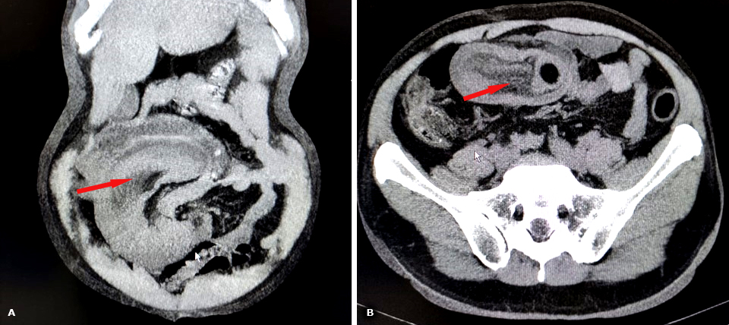
Fig. 1 - CT scan. A: a typical “sausage-like” image. B: a typical “target” image.

The diagnosis of entero-enteric intussusception was made. The patient underwent laparotomic surgery, and clinical suspicion was confirmed (Fig. 2). An intestinal (jejunal) resection was performed with a terminus-terminal anastomosis in one continuous seromuscular non-absorbable suture. The anatomopathological examination revealed a submucosal lipoma of the jejunum as a lead point. The patient successfully recovered and was discharged 3 days after surgery, without any complications.

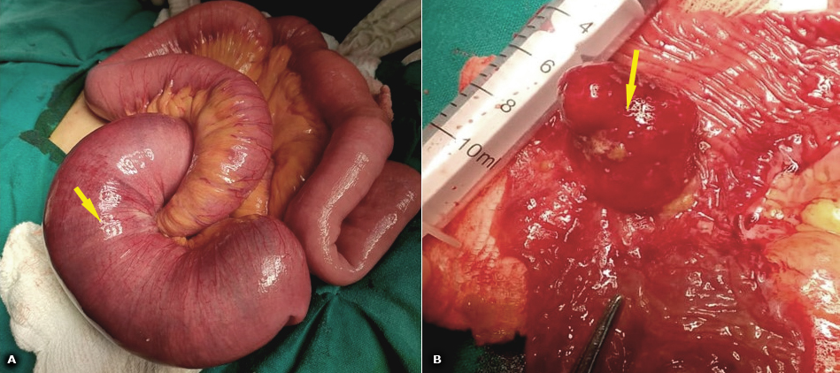
Fig. 2 - Laparotomic surgery. A: entero-enteric (jejunal) intussusception. B: Submucosal lipoma.

COMMENTS
Lipomas are rare, benign, slow growing tumors of mesenchymal cells and can be found wherever normal fat cells preside.^{(5,7,9,10)} Gastrointestinal lipomas (GL) have a reported incidence of 0.035% up to 4.4%.^{(2,7,10,11)} Of these, almost 75% are located in the large intestine and 30% in the small intestine.^{(1,2,5,7)} Small intestinal lipomas account for 2.6% of all benign gastrointestinal tumors, and generally are solitary and more commonly located in the ileum (50%) while jejunum and duodenum are the least common location.^{(1,2,8)}
A review of the literature shows only 50 cases of bowel intussusception due to lipomas reported in the first decade of the millennium, with around 21 being solitary ileal lipomas.⁽⁵⁾
The GL and specifically the small bowel ones are classified into three types.^{(7,10)} The submucosal ones are the most frequent of all with an incidence of 90% to 95%.^{(1,7)} This last one in junction with the subserosal commonly function as a lead point in the intussusceptum, but a large subserosal lipoma is prone to causing intestinal compression and volvulus.^{(1,7,10)} The intramuscular ones are less common than the others types.^{(7,10)}
GL usually presents in adults between 50 to 70 years, with no difference among sexes.^{(2,4,11)} Those < 1 cm are considered incapable of producing symptoms, and in some cases are detected incidentally.^{(2,7,11)} However, 75% of those greater than 4 cm are symptomatic due to obstruction, hemorrhage or intussusception by acting as a lead point.^{(2,7,9,11)} But only 32–50% of cases are diagnosed preoperatively.⁽²⁾
The diagnosis of GL mainly depends on imaging, and barium gastrointestinal imaging can show round, ovoid, or lobulated filling defects in the lumen of the small intestine with a smooth border, no tip, variable morphology under pressure, and normal local intestinal peristalsis and mucosa.⁽⁸⁾ In the CT scan, GL appears as a rounded low-density shadow in the intestinal lumen with CT values of −70 to 120 Hounsfield units (HU) and no enhancement after enhanced abdominal CT.⁽⁸⁾ Taking into consideration the location of GL in the gastrointestinal tract, there will be possible an endoscopic visualization by conventional, balloon, or capsule endoscopy; some endoscopic characteristics of these tumors are: a smooth, yellowish surface with pedunculated, or sessile base, “cushion sign” (the tumor indents on pressure application by biopsy forceps) and “naked fat sign” (multiple biopsies cause protrusion of yellowish fat).⁽⁵⁾
In the specific case of GL discussions continue as to whether or not a surgical approach is better than a medical reduction or an endoscopic resection.⁽²⁾ So far, when a patient presents a large and/or symptomatic lipoma, the surgical resection offers an excellent prognosis and is the standard method of treatment.^{(2,7)} Regarding the surgical approach, it is reported that laparoscopic intervention can be used in adults with intussusception with satisfactory safety and efficacy outcomes, and the conversion rate to an open procedure ranged from 0 to 16.7%.^{(2,9)} Endoscopic mucosal resection appears to have a limited role in the management of small bowel lipomas.⁽¹¹⁾
This clinical case is a rare one, not only because the intussusception is uncommon in adult patients but for the lead point found in it: a submucosal lipoma.

BIBLIOGRAPHIC REFERENCES
1. Bhansali PJ, Phatak SV, Unadkat BS, Ghanta PR. Ileal Lipoma as a Leading Point of Ileocolic Intussusception in Adult Patient: Ultrasonography and CT Evaluation. Cureus. 2022; 14(6): e26019. DOI: 10.7759/cureus.26019
2. Karampa A, Stefanou CK, Stefanou SK, Tepelenis K, Tsoumanis P, Ntalapa KM, et al. Jejunal intussusception due to an atypical lipomatous tumor: a rare case report. Journal of Surgical Case Reports. 2022; 2022(2):1–3. DOI: 10.1093/jscr/rjab624
3. Kim KH. Intussusception in Adults: A Retrospective Review from a Single Institution. Open Access Emergency Medicine. 2021; 13: 233–237. DOI: 10.2147/OAEM.S313307
4. Panzera F, Di-Venere B, Rizzi M, Biscaglia A, Praticò CA, Nasti G, et al. Bowel intussusception in adult: Prevalence, diagnostic tools and therapy. World J Methodol. 2021; 11(3):81-7. DOI: 10.5662/wjm.v11.i3.81
5. Sharma A, Thakur A. Ileocolic intussusception due to intestinal lipoma in an adult patient. Clin Case Rep. 2021; 9:1524–1528. DOI: 10.1002/ccr3.3825
6. Morais SM, Costa CS, Mourato MB, Mogne T, Santos G. Intestinal Intussusception: A Shocking Diagnosis. Cureus. 2022; 14(5): e25368. DOI: 10.7759/cureus.25368
7. Roy J, Sall K, Megaris A, DiRoma F, Mukherjee I. Submucosal Lipoma Causing Small Bowel Intussusception. Cureus. 2021; 13(8): e17367. DOI: 10.7759/cureus.17367
8. Hu Q, Wu J, Sun Y. Intussusception Related to Small Intestinal Lipomas: A Case Report and Review of the Literature. Front. Surg. 2022; 9: 915114. DOI: 10.3389/fsurg.2022.915114
9. Alshahrani AA, Alotaibi NA, Alzahrani FK, Alaqidi MF, Alabbad FA, Alqarni MA, et al. Intussusception in Adults: A Rare Etiology of Small Intestinal Obstruction. Cureus. 2021; 13(12): e20502. DOI: 10.7759/cureus.20502
10. Waack A, Nandwani S, Kolisetty K, Vattipally V. Lipoma lead point intussusception in an adult: A case report. Radiology Case Reports. 2022; 17: 4907-10. DOI: 10.1016/j.radcr.2022.09.068
11. Farkas N, Wong J, Bethel J, Monib S, Frampton A, Thomson S. A systematic review of symptomatic small bowel lipomas of the jejunum and ileum. Annals of Medicine and Surgery. 2020; 58: 52–67. DOI: 10.1016/j.amsu.2020.08.028

Conflicts of interest
The authors declare that there are no conflicts of interest. The authors declare that no funding was received for this case.

