Research article

Development of blood transfusion external quality assessment program at national scale
Desarrollo de un programa de evaluación externa de calidad de la transfusión sanguínea a nivel nacional

Chuong Le Van^{1,2} https://orcid.org/0000-0002-7648-5716
Nguyen Tran Nhat^{1,2} https://orcid.org/0000-0002-5914-6659
Van Nguyen Thi Kim³ https://orcid.org/0009-0000-9336-0897
Nhu Bui Le Thao⁴ https://orcid.org/0009-0009-9081-9071
Thu Do Thi Thanh⁵ https://orcid.org/0000-0003-3028-7279
Phuc Huynh Thi Diem^{1,2}* https://orcid.org/0000-0002-8173-4115

¹University of Medicine and Pharmacy at Ho Chi Minh City. Ho Chi Minh City, Vietnam.
²Quality Control Center for Medical Laboratory. Ho Chi Minh City, Vietnam.
³Tra Vinh University. Tra Vinh City, Vietnam.
⁴Cho Ray Hospital. Ho Chi Minh City, Vietnam.
⁵Da Nang University of Medical Technology and Pharmacy. Da Nang City, Vietnam.

*Author for correspondence. Email: diemphuc.qccump@gmail.com

ABSTRACT
Introduction: External quality assessment is a crucial component in ensuring the quality of blood transfusion testing laboratories.
Objectives: To develop a procedure for generating external quality assessment items for blood transfusion testing to evaluate participants' performance.
Methods: Experimental research was conducted at Quality Control Center for Medical laboratory- University of Medicine and Pharmacy at Ho Chi Minh City, Vietnam. Three items, including red blood cell, serum, and atypical antibody serum samples, were assessed for homogeneity and stability; 5 assessment areas, including ABO grouping, Rh grouping, compatible cross matches, Coombs test, and screening of atypical antibodies, were utilized to evaluate the performance of 38 participants in the 2020-2021 period.
Results: Red blood cell and serum samples maintained quality for a specific period at controlled temperatures, while serum samples with atypical antibodies showed stability at different temperatures. The participants demonstrated high satisfactory performance in ABO grouping, Rh grouping, Coombs test, and screening for atypical antibodies. However, the most unsatisfactory performance was reported in crossmatching, with 15% of participants unsatisfactory results.
Conclusion: The procedure of production of proficiency testing items has been successfully developed, and its application at the national level is suggested to improve the quality of blood transfusion laboratories.
Keywords: blood group; blood transfusion; quality control; red blood cell.

RESUMEN
Introducción: La evaluación externa de calidad es esencial para asegurar la calidad de los laboratorios de pruebas de transfusión sanguínea.
Objetivos: Desarrollar un procedimiento para generar elementos de evaluación externa de calidad y evaluar el rendimiento de los participantes en pruebas de transfusión sanguínea.
Métodos: Estudio experimental realizado en el Centro de Control de Calidad para Laboratorios Médicos de la Universidad de Medicina y Farmacia en la Ciudad de Ho Chi Minh, Vietnam. Se evaluaron muestras de glóbulos rojos, suero y suero con anticuerpos atípicos para homogeneidad y estabilidad. Se utilizaron 5 áreas de evaluación, incluida la agrupación ABO, la agrupación Rh, las coincidencias cruzadas compatibles, la prueba de Coombs y la detección de anticuerpos atípicos, para evaluar el desempeño de 38 participantes, en el período 2020-2021.
Resultados: Las muestras de glóbulos rojos y suero mantuvieron la calidad durante un período específico a temperaturas controladas, mientras que las muestras de suero con anticuerpos atípicos mostraron estabilidad a diferentes temperaturas. Los participantes obtuvieron un alto rendimiento en algunas áreas, como la agrupación ABO y Rh, la prueba de Coombs y la detección de anticuerpos atípicos. Sin embargo, las pruebas de compatibilidad reportaron un rendimiento insatisfactorio en un 15% de los participantes.
Conclusión: El procedimiento desarrollado cumple con los criterios de calidad, y se sugiere su aplicación a nivel nacional para mejorar la calidad de los laboratorios de transfusión sanguínea.
Palabras clave: control de calidad; glóbulo rojo; grupo sanguíneo; transfusión de sangre.

Received: 05/08/2023
Approved: 06/12/2023

INTRODUCTION
Blood transfusions are a relatively common medical procedure, and while typically safe, there are multiple complications that practitioners need to be able to recognize and treat.⁽¹⁾ There are many processes in blood transfusion to ensure safe, appropriate and compatible blood and blood products. Transfusion of red blood cells (RBC) has become a relatively common procedure.⁽²⁾ Testing the compatible blood between donated blood and recipients in the laboratory plays an important role. Total blood transfusion compatibility testing comprises ABO grouping, Rh grouping, crossmatching, Coombs test, irregular antibody screening, and antibody identification.^{(3,4)} Therefore, it is essential to ensure consistent quality and blood transfusion safety. External quality assessment (EQA) in blood transfusion laboratory practice plays a crucial role in quality control for blood transfusion services.^{(5,6)} EQA scheme compares results from different clinical laboratories to identify the accuracy and reliability of those laboratory tests. In addition, based on the report results from participating laboratories, EQA program can provide valuable profits to identify systematics problems associated with the operation, training in need, and indicate areas that need improvements.⁽⁷⁾
Unlike other EQA schemes, which can utilize lyophilized samples, EQA provider must use the human RBC for the blood transfusion EQA program, which requires strict transport condition regarding temperature. Therefore, it isn't easy to build up an international EQA program, that is the reason why World Health Organization (WHO) encourages each country should develop a national blood transfusion EQA program.⁽⁷⁾ Producing stable and homogenous samples for blood transfusion EQA program is challenging. Herein, the production procedure of RBC, serum, atypical antibody serum samples for blood transfusion EQA scheme is presented, and the performance results of participating laboratories from 2020 to 2021.
This study aimed to develop procedure for generating blood transfusion EQA items to evaluate participants' performance.

METHODS
The study was conducted at the Quality Control Center for Medical Laboratory (QCC) - University of Medicine and Pharmacy at Ho Chi Minh City (UMP) from January 2020 to December 2021. The study was approved by the Ethics Committee in Biomedical Research of the UMP.
Research method and subjects: Empirical research of RBC, serum, atypical antibody serum samples and descriptive statistics for the efficiency of establishing blood transfusion external quality assessment program for laboratory units that performed blood transfusion EQA program provided by QCC.
Inclusion criteria: The whole blood bags were collected within 7 days from blood bank, which have negative results with malaria, syphilis, Hepatitis B, Hepatitis C and Human Immunodeficiency virus, direct and indirect Coombs test.
The plasma which contains atypical antibodies must comprise at least one specifically identified atypical antibody.
The blood collection, preservation, and storing process according to blood bank procedure, which takes a part from national criteria guideline for Blood transfusion.
Exclusion criteria: Whole blood bags were collected above 7 days, serum samples are thawed more than 3 times.
Production of RBC, serum, and atypical antibody serum samples: Fourth lots of red blood cells and serum including sample lot 1 (group A), sample lot 2 (group B), sample lot 3 (group AB) and sample lot 4 (group O) have produced. Shortly, whole blood cell samples were centrifuged 2 times at 2000 rpm in 5 minutes to separate plasma. The RBC was diluted with normal saline and centrifuged at 2000 rpm for 5 minutes. This step was repeated 2-3 times to eliminate buffy coat (leukocyte and platelet) then the RBC was diluted in Alsever preservative solution to produce a 5% RBC solution.⁽⁷⁾ The solution was distributed to tubes (2 mL/tube) then stored at 2-6 °C. After separation, the plasma was converted to serum according to WHO guidelines.⁽⁸⁾ The serum was supplemented with sodium azide (0.1g/100 mL), then delivered into a sterile, covered test tube and stored at 2-6 °C.
The RBC panel (AbtectcellTMIII/ PhenocellTMC, Grifols, Spain) and Gel card system (Neutral ID-card, and LISS/Coombs ID-card, Grifols, Spain) were utilized to identify atypical antibodies. The plasma was converted to serum then distributed to tubes (2 mL/tube). Four batches of atypical antibody serum (AAS) have been produced comprising AAS-1 (anti E), AAS-2 (anti c), AAS-3 (anti E-c) and AAS-4 (anti Fy^{b}). The producing AAS samples were stored at 2-6 °C and -20 °C for further evaluation.
Evaluation of homogeneity: For each red RBC and serum batch, 10 samples were randomly chosen to evaluate the homogeneity in accordance with ISO Guide 35:2017 and ISO 17043:2023.⁽⁹⁾ For red blood cells, the coefficient variance (CV) < 3.0% was assumed as homogenous sample.⁽¹⁰⁾ The level of hemolysis was classified to 4 levels, including level 0: non-hemolysis (free hemoglobin (FHb) <500 mg/L), level 1: minor hemolysis (500 < FHb < 1000 mg/L), medium hemolysis (1000 < FHb < 2000mg/mL and major hemolysis (FHb ≤ 2000 mg/mL). Moreover, Antigen, Hematocrit (Hct), Hemoglobin (Hb), K⁺, Na⁺, Lactate, and Lactate dehydrogenase (LDH) parameters were included to evaluate the homogeneity. For serum samples, homogeneity was assessed based on the degree of agglutination with corresponding erythrocytes and the antibody titers must reach from 16 to 32.
Identification of antibody titer: The AAS samples were multiplied, continuously diluted with normal saline (2nd dilution) from 1:2 to 1:1024. The original AAS and diluted AAS samples were interacted with correspondence antigens by tube test (TT; low ionic strength solution (LISS)/anti-human globulin (AHG)) and Column agglutination test (CAT; Neutral ID-card, and LISS/Coombs ID-card, Grifols, Spain).
Evaluation of stability: In accordance with ISO Guide 35:2017, the RBC samples were stored at 2-6 °C and long-term stability was evaluated by measuring the important parameters at each period including day zero, 7, 35, 42, and day 49. The t-test was utilized to check the stability of all parameters over the period of time and p-value > 0.05 was set to accept change. The antigen, RBC, Hct, Hb, K⁺, Na⁺, Lactate, and LDH parameters were utilized to evaluate the stability. Serum samples are stored at 2-6°C and assessed for long-term stability based on antigen-antibody aggregation and antibody titers. Each period, 3 samples were randomly chosen to be analyzed 3 times to ensure the objectivity.
The long-term stability of AAS samples were tested relying on p-value of the total score of antibody titer, and p-value > 0.05 was set for minor variation that means samples were stable. The long-term stability of AAS samples was evaluated in 1 month, 2 months, and 3 months at 2-6°C and -20°C. Each period, 3 samples were randomly chosen to be analyzed 3 times by two methods TT and CAT.
Appling RBC and atypical antibody serum for blood transfusion EQA program: To evaluate performance of the participants (38 laboratories) EQA samples (comprised 3 tubes of 3 donor RBC samples and 3 tubes of RBC as well as serum samples of 3 recipients) were sent to the laboratories every 2 months (each EQA round produced, the new one was sent to participant). Five areas of assessment were collected and analyzed including ABO grouping, Rh grouping, compatible crossmatches, Coombs test, screening of atypical antibodies. Participants were scored on their interpretations in each of tests for which they were registered, and for non-return of results. The scoring system was assessed according to Annex 10 of WHO's Guidelines on establishing an EQA scheme in blood group serology.⁽⁷⁾ Cumulative Sum (CUSUM) points are calculated based on recently three cycles (CUSUM range: 0 – 79 was assumed as satisfactory; 80 – 99 was a borderline; 100 – 150 was unsatisfactory). Twelve cycles have been collected in 2 years (2020-2021) by both TT (n= 14) and CAT (n= 24) methods.
The method of data collection and statistical analysis: summarizing the blood transfusion external quality assessment results of laboratories returning to QCC. Data were entered and analyzed using Microsoft Excel 2019.

RESULTS
Three batches of RBC, serum, and atypical antibody serum samples have been produced, and assessed the homogeneity and stability in accordance with ISO Guide 35: 2017. In addition, 5 areas of assessment including ABO grouping, Rh grouping, compatible crossmatches, Coombs test, and screening of atypical antibodies were utilized to evaluate the performance of participants (n= 38) in 2020-2021.
According to the limitation of this pilot study, 4 RBC sample lots (including sample lot 1: group A, sample lot 2; Group B, sample lot 3: Group AB, and sample lot 4: Group O) have been produced. All sample lots were checked for homogeneity based on the value of CV% of indicator parameters.

Table 1 - The homogeneity of red blood cell samples
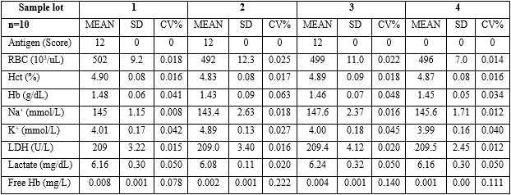
RBC: Red blood cell; Hct: Hematocrit; Hb: Hemoglobin; LDH: Lactate dehydrogenase; SD: Standard deviation; CV: Coefficient variance.

Table 1 shows that the entire blood group antigens were preserved and had no change in CV%. The other parameters-maintained CV% less than < 3% (sample 1 has CV% ranges from 0.8% to 7.8%; sample 2: 1.6% - 22%; sample 3: 1.6% - 14%; and sample 4: 1.4%-11%).
Table 2 shows that all antigen of blood groups preserved stability during the observed times. Nevertheless, the RBC stables up to day 35 (p> 0.05) then degraded up to 10% at day 49 compared to zero-day. Similarly, the Hct and Hb parameters were stable up to day 35. The concentration of sodium ions decreased time by time from 145 mmol/L at day zero to 118.67 mmol/L at day 49. Whereas, the concentration of potassium ions increased from 4.01 to 7.70 mmol/L. The LDH and lactate parameters also vigorously increased from 209 to 290 mmol/L and 6.16 to 10.4 mmol/L respectively.
Three serum sample lots (including sample lot 1: group A, sample lot 2; Group B, sample lot 3: Group O) have been produced. The results of the homogeneity assessment showed that whole items in groups A, B, and O respectively got at 4⁺ (12 points) agglutinating with erythrocytes; and all antibody titer reached 32 (table 3).
The results of the long-term stability assessment of serum samples from day 0 to 49 showed that all serum samples in groups A, B, and O have strong antibody activity, agglutinating with the corresponding erythrocytes at 4+ (12 points) and antibody titers reached 32.
Four batches of serum containing atypical antibodies (AAS-1; AAS-2; AAS-3 and AAS-4) have been produced. The AAS-1 contained anti E, AAS-2 comprised anti c, AAS-3 encompassed anti E-c and AAS-4 (anti Fy^{b}). Each batch was delivered to 40 sterile tubes (2 mL each). The antibody titers of producing sample were evaluated by both tube test (TT) and CAT methods. The lowest ratio of dilution was 1:2 and the highest one was 1:32 according to identified method. The results show that the antibody titer which is identified by CAT was significantly higher by the TT method (table 4).

Table 2 - The long-term stability of red blood cell samples
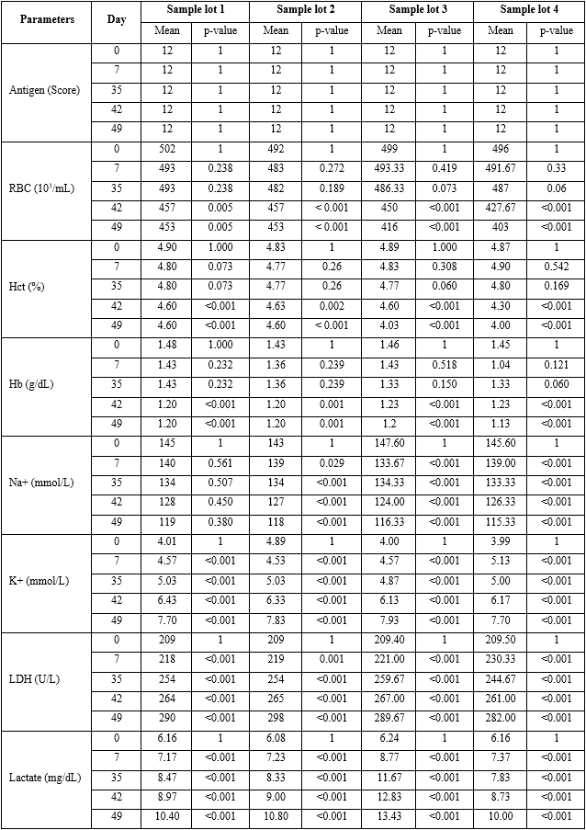
RBC: Red blood cell; Hct: Hematocrit; Hb: Hemoglobin; LDH: Lactate dehydrogenase; SD: Standard deviation; CV: Coefficient variance.

Table 3 - Homogeneity assessment of serum samples
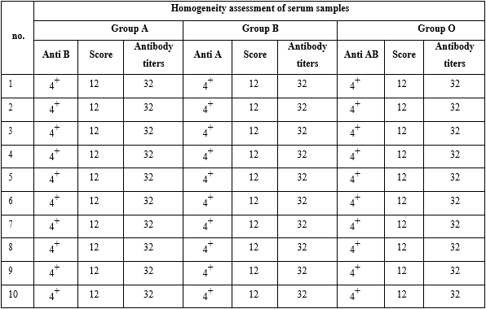

Table 4 - The antibody titer identified by tube test (TT)
and Colum agglutination technology (CAT)
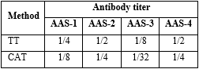

The long-term stability of AAS samples were tested. The results revealed that the samples stored at -20°C were stable for up to 3 months. Nevertheless, the samples stored at 2-6°C were stable within 2 months by both methods.
The blood transfusion compatibility testing performance of participating laboratories was evaluated based on 5 areas of assessment including ABO grouping, Rh grouping, compatible crossmatches, Coombs test and screening of atypical antibodies (Fig. 1).

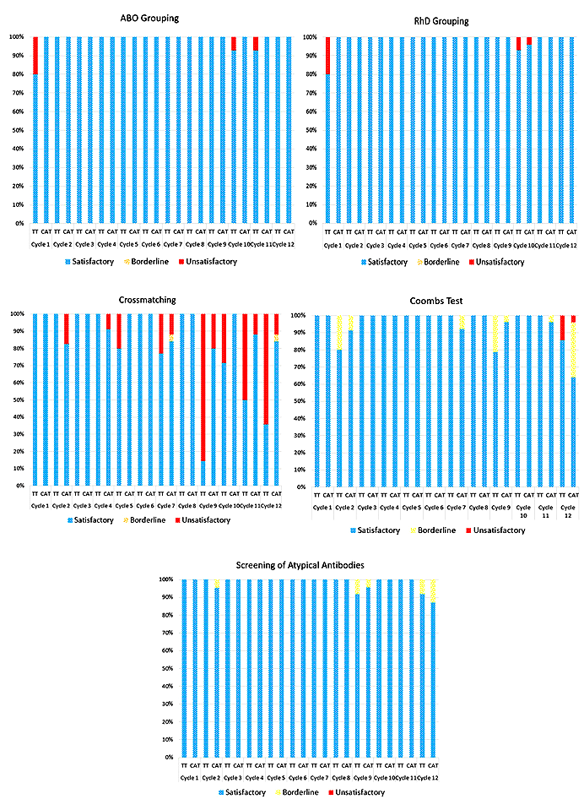
Fig. 1 - The performance of participating blood transfusion compatibility laboratories (ABO grouping, Rh grouping, compatible crossmatches, Coombs test, and screening of atypical antibodies); TT: tube test (n= 14); CAT: Colum agglutination technology (n= 24).

The results show excellent accuracy (100%) in ABO grouping by CAT method. However, in some cycles, the performance of ABO grouping was achieved only 80-92% by using TT method. Similarly, in Rh grouping the CAT method reached 96-100% while TT method has performance from 80 to100%. The most unsatisfactory performance was shown in compatible crossmatching, especially in cycle 9, up to 90% of participants were classified as having unsatisfactory performance. The good performance was recorded in Coombs test performance, except cycle 12. All participants seem to be excellent accuracy in the screening of atypical antibodies, excluding cycles 2, 9, and 12 there are some laboratories categorized as a borderline in performance.

DISCUSSION
The blood transfusion compatibility testing (by both manual and automated testing) analyzes the reaction activity of RBC blood group antigens and serum blood group antibodies. Therefore, one of the most important requirements of EQA samples is commutable and mimic to the clinical samples. The process of EQA sample production must be met the criteria of homogeneity and stability in accordance with ISO Guide 35:2017.⁽¹¹⁾ Especially, RBC sample is a suspension, its homogeneity must be primary concern. One of the features of EQA products must be reduced variation between vial to vial. All produced RBC lots were homogenous illustrated by 9 assay parameters. The RBC samples must be stable during the time from production until tested by participants. The produced RBC samples were stable within 35 days in reserve condition. This result was similar to the outcome of the study of Yu Y. et al.⁽⁴⁾ Although produced RBC samples ensured the standards of clinical practice until 49 days, ion sodium, potassium, and LDH are important indices that reveal RBC degeneration have been reported alteration.⁽⁴⁾
Three serum batches (anti-A, anti-B, and anti-AB) showed accepted homogeneity and stability. Since all of them are nature antibodies, their antibody titers reached 32 and were reserved for up to 49 days at 2-6 °C. To evaluate the quality of atypical antibody serum, the titers of antibodies were tested by both TT and CAT methods. Four sets of atypical antibody serum have titers ranging from 2 to 32. The low titer of the antibodies was also included to evaluate the performance of participating laboratory. The CAT is more sensitive than the TT method (the result is statistically significant difference at p value is < 0.00001). For long-term reservation, serum should be frozen at -18 °C or lower.^{(12,13)} The stability of atypical antibody serum samples in 2-6°C (shipping condition) was also investigated. In this condition, the sample was stable for up to 2 months, suitable for delivering in the same condition as RBC samples.
The blood transfusion EQA program could ensure quality blood transfusion service of participating laboratories via measurement of performance and identification of any problems and deficiencies. Among all areas of total blood transfusion compatibility testing, antibody identification was not routinely performed by almost all laboratories. Five areas of assessment (ABO grouping, Rh grouping, compatible cross matches, coombs test, screening of atypical antibodies) have been utilized to evaluate the performance of participating laboratories. Overall, admirable performance was achieved in the ABO grouping, except some cycles have unsatisfactory performance by the TT method. In the Rh grouping, almost all participants have good performance. Weak D antigen is a phenotype where the D antigen is weakly expressed on red blood cells, and this antigen cannot be detected by routine methods.⁽¹⁴⁾ Although weak D antigen samples were not included in any cycles, few participants got unsatisfactory performance in Rh grouping.
The most unsatisfactory performance has been reported in crossmatching, especially in cycles using atypical antibody serum samples as recipient serum (cycle 2, 5, 7, 9, 11, and 12). The unsatisfactory performance in crossmatching here was not only variable by the method but also by the using enzymes in blood group serology. There are many groups of atypical antibodies, antibody against the Rh system is the most common cause of incompatibility.⁽¹⁵⁾ Irregular antibody screening plays a vital role in ensuring the safety and compatibility of blood transfusions. This test has been evaluated on an internal quality control products in the study of Xu Ping-Gui et al.⁽¹⁶⁾ In this program, just 4 atypical antibody types were applied. Therefore, almost all participants got satisfactory performance in antibody screening.
The red blood cell samples were homogeneous, stable for 35 days, and still ensure the standards of clinical practice until 49 days. Serum samples reach homogeneity and stability up to 49 days. The atypical antibody serum samples were stable for more than 3 months at -20 °C and 2 months at 2-6 °C. The produced items met the criteria of EQA samples according to ISO Guide 35: 2017.
The produced samples reach the criteria of EQA sample for the blood transfusion EQA program. The blood transfusion testing performance of participating laboratories in 2020-2021 was acceptable except for crossmatching. The blood transfusion EQA program aims to improve performance standards in blood transfusion laboratories, therefore, improving quality of blood transfusion.
The procedure of production of proficiency testing items has been successfully developed, and its application at the national level is suggested to improve the quality of blood transfusion laboratories.

Acknowledgments
We would like to thank the QCC - UMP and Blood Transfusion Center – Cho Ray Hospital for facility to finish this research.

BIBLIOGRAPHIC REFERENCES
1. Lotterman S, Sharma S. Blood Transfusion. Treasure Island (FL): StatPearls Publishing; 2023. [access: 20/02/2023]. Available at: https://www.ncbi.nlm.nih.gov/books/NBK499824/
2. Yoshida T, Prudent M, D'alessandro A. Red blood cell storage lesion: causes and potential clinical consequences. Blood Transfus. 2019;17(1):27-52. DOI: 10.2450/2019.0217-18
3. Basavarajegowda A, Shastry S. Pretransfusion Testing. Treasure Island (FL): StatPearls Publishing; 2023. [access: 18/02/2023]. Available at: https://www.ncbi.nlm.nih.gov/books/NBK585033/
4. Yu Y, Ma C, Feng Q. Establishment and performance assessment of preparation technology of internal quality control products for blood transfusion compatibility testing. Exp Ther Med. 2013; 5(5):1466-70. DOI: 10.3892/etm.2013.994
5. WHO. Overview of External Quality Assessment (EQA); 2009 [access: 07/06/2022]. Available at: https://cdn.who.int/media/docs/default-source/essential-medicines/norms-and-standards/10-b-eqa-contents.pdf?sfvrsn=181d9a32_4&download=true
6. Johnson P., Cabuang L. Proficiency testing and ring trials. Rev. Sci. Tech. 2021;40:189–203. DOI: 10.20506/rst.40.1.3217
7. WHO. External quality assessment of transfusion laboratory practice. Guidelines on establishing an EQA scheme in blood group serology. Blood Transfusion Safety. Geneva; 2004 [access: 25/12/2022]. Available at: https://www.who.int/publications/i/item/9241591250
8. WHO. WHO manual for organizing a national external quality assessment programme for health laboratories and other testing sites. Geneva: WHO; 2016. [access: 04/12/2021]. Available at: https://apps.who.int/iris/handle/10665/250117
9. International Organization for Standardization. ISO/IEC17043:2023. Conformity -General Requirements for Proficiency Testing. The International Organization for Standardization; Geneva. Switzerland: ISO; 2023. [access: 18/02/2023]. Available at: https://www.iso.org/standard/80864.html
10. International Organization for Standardization. ISO Guide 13528. Statistical methods for use in proficiency testing by interlaboratory comparisons. Geneva: ISO; 2022. [access: 20/12/2022]. Available in: https://www.iso.org/obp/ui/#iso:std:iso:13528:ed-3:v1:en
11. WHO. Reference materials — General and statistical principles for certification. ISO Guide 35. Geneva; WHO; 2017. [access: 04/12/2021]. Available at: https://www.iso.org/standard/60281.html
12. Khawar H, Kelley W, Stevens JB. Fresh Frozen Plasma (FFP). Treasure Island (FL): StatPearls Publishing; 2023. [access: 04/03/2023]. Available at: https://www.ncbi.nlm.nih.gov/books/NBK513347/
13. Basu D, Kulkarni R. Overview of blood components and their preparation. Indian J Anaesth. 2014; 58(5):529-537. DOI:10.4103/0019-5049.144647
14. Brar RK, Shaiji PS, Sehgal S. Testing for weak D Antigen: Spectrum and its applied role in rhesus-negative transfusions in Andaman and Nicobar Islands. 2019;32(2):167-170. DOI: 10.4103/tcmj.tcmj_222_18
15. Bhattacharya P, Samanta E, Afroza N, Archana N, Biswas R. An approach to incompatible cross-matched red cells: Our experience in a major regional blood transfusion center at Kolkata, Eastern India. Asian journal of transfusion science. 2018; 12(1):51-6. DOI: 10.4103/ajts.AJTS_157_16
16. Xu GP, Wu LF, Li JJ, Gao Q, Zhi-Dong OL, Qiong-Hua K, et al. Performance Assessment of Internal Quality Control (IQC) Products in Blood Transfusion Compatibility Testing in China. PLoS One. 2015;10(10):e0141145. DOI: 10.1371/journal.pone.0141145

Conflicts of interest
None of conflicts of interest in relation to the work.

Authorship contribution
Conceptualization: Chuong Le Van.
Data curation: Nguyen Tran Nhat.
Formal analysis: Van Nguyen Thi Kim.
Research: Thu Do Thi Thanh, Nhu Bui Le Thao, Van Nguyen Thi Kim.
Methodology: Nguyen Tran Nhat.
Supervision: Chuong Le Van.
Validation: Nhu Bui Le Thao.
Writing – original draft: Van Nguyen Thi Kim, Nguyen Tran Nhat.
Writing – review and editing: Chuong Le Van, Phuc Huynh Thi Diem.

